ECS Fargate Deploiement

1-create cluster

2-create a task definition :

It is important to specify a task role (ecsTaskExecutionRole)

In this part of the configuration, the Image URI should be tagged with "latest" so that each time the pipeline is relaunched, it automatically uses the most recent image version.

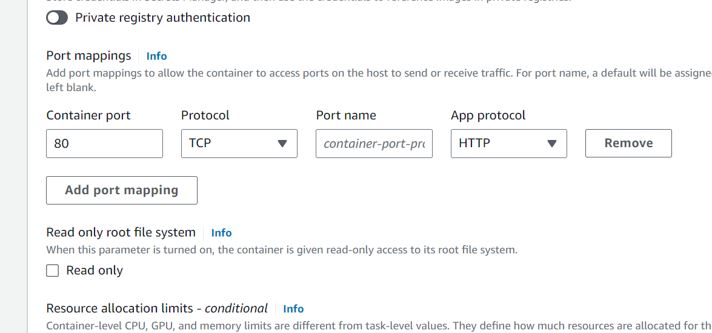

**Port Consistency**: For the ECS Task Definition to function correctly, the **container port** specified in the ECS configuration must match the port exposed in the Dockerfile. For example, if your Dockerfile exposes port 8080, you must specify 8080 as the container port in the Task Definition.

3-create service

In networking configuration we

we chose to use the **default VPC** provided by AWS

4-Testing Deploiement

